**Chapter 1: Introduction**

* 1. **Background:**

A Training and Placement Management System is a software solution that facilitates the seamless connection between students seeking job placements and companies offering employment opportunities. It streamlines tasks like resume management, interview scheduling, and feedback collection, making the placement process efficient for educational institutions and organizations. This system enhances career development and fosters partnerships between academia and industry. Overall, a Training and Placement Management System plays a pivotal role in shaping the future careers of students and strengthening the relationships between academic institutions and the corporate world.

* 1. **Objective:**

1. Training and Placement Management System is a software platform designed to streamline and improve the process of student placements in educational institutions.
2. It serves as a central database for student profiles, allowing easy access to their resumes, academic records, and career preferences.
3. Employers can post job openings and directly interact with students through the system, simplifying the recruitment process.
4. The system automates tasks like interview scheduling and feedback collection, reducing administrative burdens for institutions.
5. It provides valuable data and analytics to institutions for better understanding student placement trends and improving training programs.
6. Overall, the Training and Placement Management System bridges the gap between students and employers, making the placement process more efficient and effective.
   1. **Scope of the Project:**
7. Student Profile Management: Creating a centralized database for managing student profiles, encompassing academic records, resumes, and career preferences.
8. Job Posting and Application: Implementing a user-friendly interface for employers to post job openings and students to apply for positions directly through the system.
9. Interview Coordination: Developing features for automated interview scheduling, ensuring efficient communication between students and employers.
10. Feedback and Evaluation: Integrating feedback mechanisms to collect evaluations from employers’ post interview, providing insights for both students and institutions.
11. Analytics and Reporting: Incorporating data analytics tools to generate reports
12. on placement trends, enabling institutions to make data driven decisions.
13. Security and Privacy: Ensuring robust security measures to protect sensitive student and employer data, complying with data privacy regulations.
    1. **Existing System:**
14. Manual Processes: In many cases, placement processes still heavily rely on manual tasks, including paper-based resume submissions and phone-based interview scheduling, leading to inefficiencies and delays.
15. Data Fragmentation: Student data, including academic records and resumes, is often stored in disparate locations, making it challenging to maintain a comprehensive overview of student profiles.
16. Limited Accessibility: Existing systems may lack user-friendly interfaces, hindering access and usability for both students and employers.
17. Communication Gaps: Inefficient communication channels between students, employers, and placement offices can lead to miscommunication and missed opportunities.
18. Lack of Analytics: Most existing systems lack robust analytics and reporting capabilities, making it difficult for institutions to gain insights into placement trends and areas for improvement.
19. Security Concerns: Data security is often a concern, with potential vulnerabilities in outdated systems that may not comply with modern privacy regulations.
    1. **Proposed System:**
20. Automation: The new system will automate various aspects of the placement process, including resume submission, interview scheduling, and feedback collection, reducing manual effort and streamlining operations.
21. Centralized Database: It will establish a centralized database for managing student profiles, academic records, and career preferences, ensuring easy access and comprehensive information for both students and employers.
22. User-friendly Interface: The system will feature an intuitive and user-friendly interface, enhancing accessibility and usability for all stakeholders, including students, employers, and placement office staff.
23. Efficient Communication: Improved communication channels within the system will facilitate seamless interactions between students and employers, reducing communication gaps and misunderstandings.
24. Data Analytics: Robust analytics and reporting capabilities will provide institutions with valuable insights into placement trends, enabling data driven decision making and continuous improvement.
25. Enhanced Security: Stringent security measures will be implemented to safeguard sensitive data, ensuring compliance with data privacy regulations and instilling confidence in users.
    1. **Limitation:**
26. Initial Implementation Costs: Setting up the system can require a significant upfront investment in terms of software development, infrastructure, and training.
27. User Adoption: Encouraging all stakeholders, including students, employers, and placement office staff, to fully adopt the system may be challenging, especially in institutions with existing manual processes.
28. Data Accuracy: The system heavily relies on accurate data input, and any inaccuracies or outdated information can lead to issues in matching students with suitable job opportunities.
29. Privacy Concerns: Despite security measures, data breaches are always a potential risk, and institutions must remain vigilant to protect sensitive student and employer information.
30. Technical Support: Maintaining a system of this complexity requires dedicated technical support, and institutions must ensure they have the resources and expertise to address any technical issues that may arise.
31. Integration Complexity: Integrating the system with existing institutional databases and systems can be complex and time-consuming, potentially causing disruptions during implementation.

**Chapter 2: Requirement Specification**

**2.1 Hardware Requirements:**

The training and placement cell management system requires basic hardware components, including a server or hosting environment with sufficient processing power and memory. Additionally, client devices like computers or smartphones need internet connectivity to access the system efficiently. Overall, modest hardware resources can support the smooth operation of this system.

**2.1.1 Processor:**

The training and placement cell management system demands a processor with at least a dual core configuration, ensuring efficient data processing and responsiveness. A quadcore processor is recommended for larger institutions with higher usage requirements, as it can handle concurrent tasks more effectively. However, the system is generally not resource intensive, making it compatible with a wide range of processors.

**2.1.2 Memory:**

For the training and placement cell management system, a minimum of 4GB RAM is sufficient to handle routine operations and data processing. However, for optimal performance, especially in larger institutions, it's advisable to have 8GB or more of RAM to ensure smooth multitasking and faster data retrieval. The memory requirements can vary based on the user load and database size but generally remain within this range.

**2.1.3 Storage:**

The training and placement cell management system typically requires around 2050GB of storage space to accommodate the application, databases, and associated files. This estimate can vary depending on the institution’s data volume and growth projections. It’s essential to periodically monitor and expand storage capacity as needed to ensure seamless operation.

**2.1.4 Software Requirements:**

To develop a training and placement cell management system, you’ll need XAMPP for a local web server environment, MySQL for data storage, and Java with NetBeans as an integrated development environment. XAMPP streamlines server setup, MySQL handles data management, and Java in NetBeans provides a powerful platform for building the system’s features efficiently.

**2.2.1 Operating System:**

The training and placement cell management system is highly adaptable, supporting multiple operating systems, including Windows, Linux, and macOS. This cross-platform compatibility ensures that institutions can implement the system on their preferred OS environment. Whether it’s Windows for familiarity, Linux for stability, or macOS for design focused environments, the system accommodates various OS choices, making it accessible to a wide range of users.

* + 1. **Frontend:**

For the frontend development of the training and placement cell management system using Java within the NetBeans integrated development environment, the following requirements are pivotal:

1. Java with NetBeans: Employ Java as the core programming language, leveraging NetBeans as the integrated development environment (IDE) to facilitate seamless frontend development.
2. GUI Design: Utilize NetBeans’ GUI Builder to create intuitive and visually appealing user interfaces, simplifying the process of designing and arranging components.
3. Code Debugging and Profiling: Leverage NetBeans’ debugging and profiling tools to identify and resolve issues efficiently, ensuring a smooth and errorfree user experience.
4. Integration Capabilities: Utilize NetBeans’ capabilities for easy integration with backend components, ensuring data flow and synchronization between the frontend and database.
5. Cross Platform Compatibility: Benefit from Java’s inherent cross platform compatibility, allowing the system to function consistently on various operating systems.
6. Community and Plugin Support: Tap into NetBeans’ active community for guidance and access to a wide range of plugins and extensions that can enhance development productivity and expand functionality.

Incorporating Java within the NetBeans environment ensures a robust, visually appealing, and well-integrated front end for the training and placement cell management system, ultimately delivering a user-friendly and efficient interface.

* + 1. **Backend:**

For the backend of the training and placement cell management system, relying on MySQL within the XAMPP environment is crucial, and the following requirements are essential:

1. MySQL Database: Utilize MySQL as the relational database management system (RDBMS) to store and manage data efficiently, ensuring data integrity and reliability. XAMPP Server: Implement XAMPP, which includes the Apache web server and PHP, to provide a comprehensive web server environment for hosting the system, facilitating seamless data access and interactions.
2. Database Design: Employ sound database design principles to create well-structured tables, relationships, and queries that optimize data storage and retrieval, ensuring system responsiveness.
3. Security Measures: Implement robust security measures within both MySQL and XAMPP to protect sensitive data and prevent unauthorized access, including firewalls, encryption, and user authentication.
4. Scalability and Backup: Plan for system scalability by optimizing database performance and regularly backing up data to safeguard against data loss and system downtime.
5. Compatibility: Ensure compatibility with various operating systems, as XAMPP and MySQL are available for Windows, Linux, and macOS.

Incorporating MySQL within the XAMPP environment establishes a solid backend foundation for the training and placement cell management system, offering secure and efficient data management capabilities while ensuring compatibility and scalability.

* + 1. **Database:**

For the training and placement cell management system, MySQL serves as the primary database system, with the central requirement being:

* MySQL Database: The system relies on MySQL as the core relational database management system (RDBMS) for efficient data storage, retrieval, and management, ensuring data integrity and reliability. MySQL offers a reliable foundation for the system’s data needs, facilitating seamless operations and secure data handling.
  + 1. **IDE:**

For developing the training and placement cell management system, the NetBeans integrated development environment (IDE) is chosen, with the main requirement being:

* NetBeans IDE: Utilize NetBeans as the primary development environment for building the system’s software components. NetBeans offers a rich set of features, including code editing, debugging, and a user-friendly GUI Builder, which simplifies the creation of intuitive and visually appealing user interfaces. This IDE streamlines the development process, enhances code quality through debugging and profiling tools, and provides access to a supportive community and a wide range of plugins, ensuring efficient development and maintenance of the system.
  + 1. **Framework:**

For the training and placement cell management system, Java based framework requirements are vital, with the central point being:

* Java Framework: Choose a Java based framework such as Spring or Java EE to build the system’s architecture. These frameworks provide essential features like dependency injection, transaction management, and MVC patterns, ensuring robust and scalable application development. Utilizing Java frameworks promotes code reusability, maintainability, and compatibility with various databases, making it an ideal choice for constructing a reliable and adaptable system.
  + 1. **Functional requirements:**

The functional requirements of the training and placement cell management system encompass essential features for its efficient operation:

1. User Authentication: Implement secure login and role-based access control for students, faculty, and administrators.
2. Student Profile Management: Enable students to create, update, and maintain their academic profiles, including resumes and preferences.
3. Job Posting and Matching: Allow employers to post job opportunities and provide students with a job matching system based on their profiles.
4. Interview Scheduling: Enable students to schedule interviews with employers, with automated notifications and reminders.
5. Analytics and Reporting: Provide administrators with tools for tracking placement trends, monitoring student performance, and generating insightful reports to improve the placement process.

These functional requirements ensure that the training and placement cell management system effectively serves its purpose by facilitating seamless interactions between students, employers, and administrators while optimizing the placement process.

* + 1. **Nonfunctional Requirements:**

The nonfunctional requirements for the training and placement cell management system focus on aspects that contribute to its overall performance, security, and user experience:

1. Performance: The system should offer low latency and high responsiveness, ensuring quick access to information even during peak usage times.
2. Security: Robust security measures, including data encryption, role-based access control, and regular security audits, must be in place to protect sensitive student and employer data.
3. Scalability: The system should be capable of handling increasing data loads and user traffic, allowing for scalability as the institution grows.
4. Reliability: Ensure high availability and minimal downtime through redundant server configurations and regular maintenance.
5. Usability: Prioritize an intuitive and user-friendly interface, requiring minimal training for students, faculty, and employers to use the system effectively.

These nonfunctional requirements collectively contribute to a dependable, secure, and efficient training and placement cell management system that meets the performance and usability expectations of its users

**Chapter 3: System Designs**

**3.1 Flowchart:**

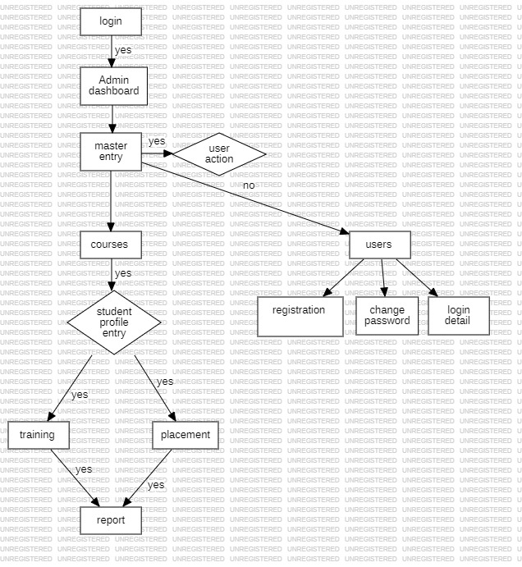

**Fig 3.1.1 Flowchart**

**3.2 Data Flow Diagram:**

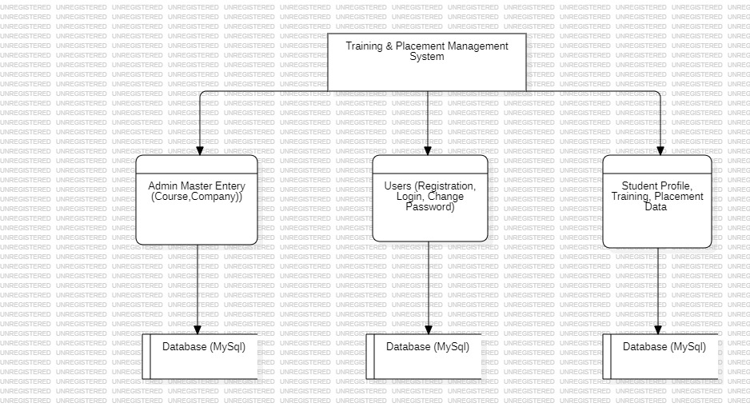

**DATAFLOW DIAGRAM LEVEL 0**

**Fig 3.1.1 DATAFLOW DIAGRAM LEVEL 0**

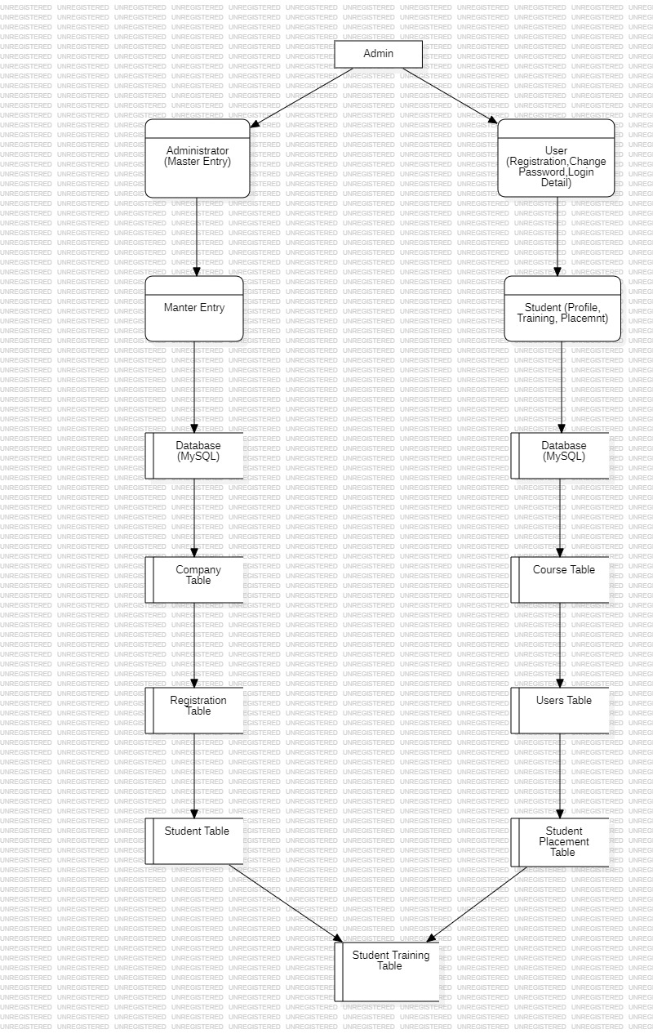

**DATAFLOW DIAGRAM LEVEL 1**

**Fig 3.1.2 DATAFLOW DIAGRAM LEVEL 1**

**3.3 Gantt Chart:**

A Gantt Chart could be a variety of chart that illustrates a project schedule. This chart lists the tasks to be performed on the vertical axis and time intervals on the horizontal axis. The width of the horizontal bars in the graph shows the duration of the activity. The Gantt chart illustrates the start and finishes dates of the terminal elements and the summary elements of a project. Gantt charts are usually created initially using an early start time approach. When each task is scheduled to start immediately when its prerequisites are completed.

**3.4 Pert Chart:**

**3.5 ER Diagram:**

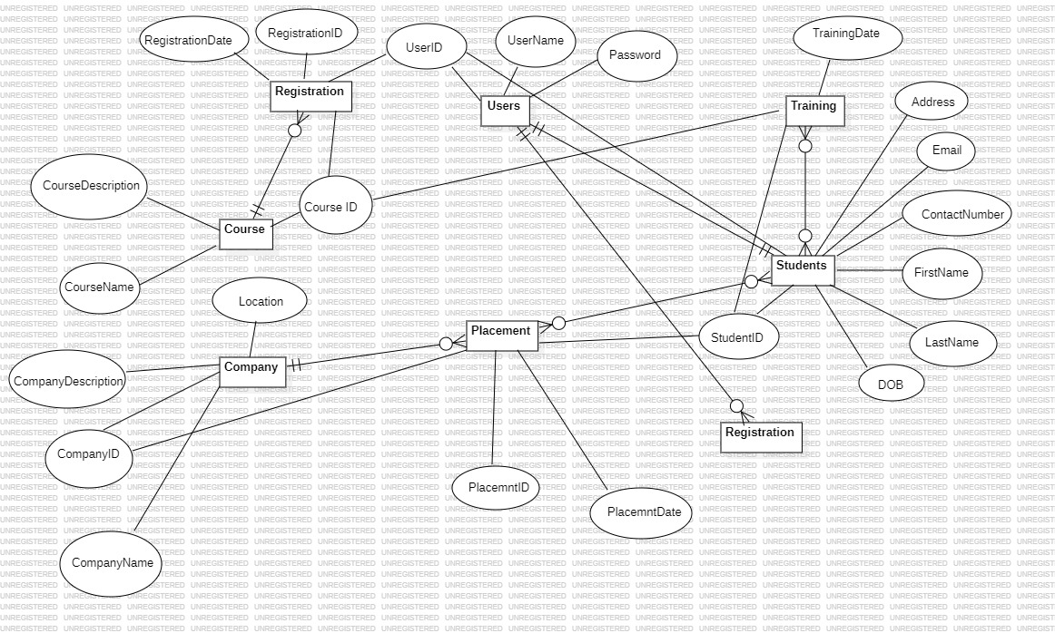

**Fig 3.1.5 ER Diagram**

**3.6 Use Case Diagram:**

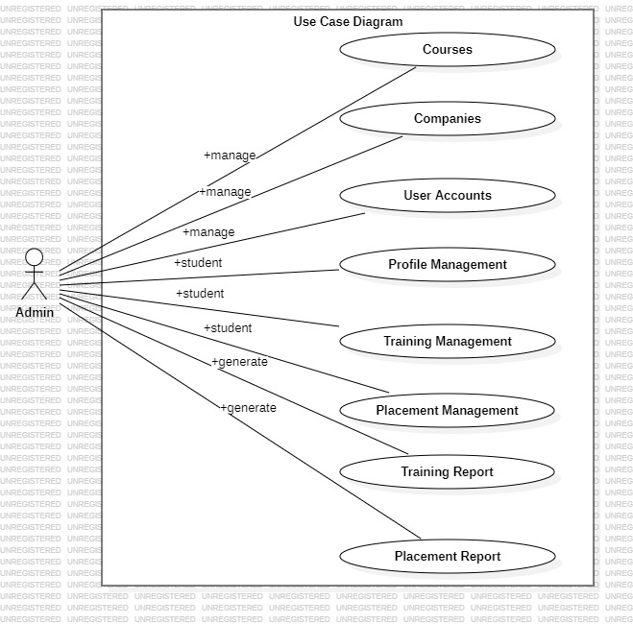

**Fig 3.1.6 Use Case Diagram**

**3.7 UML Diagram:**

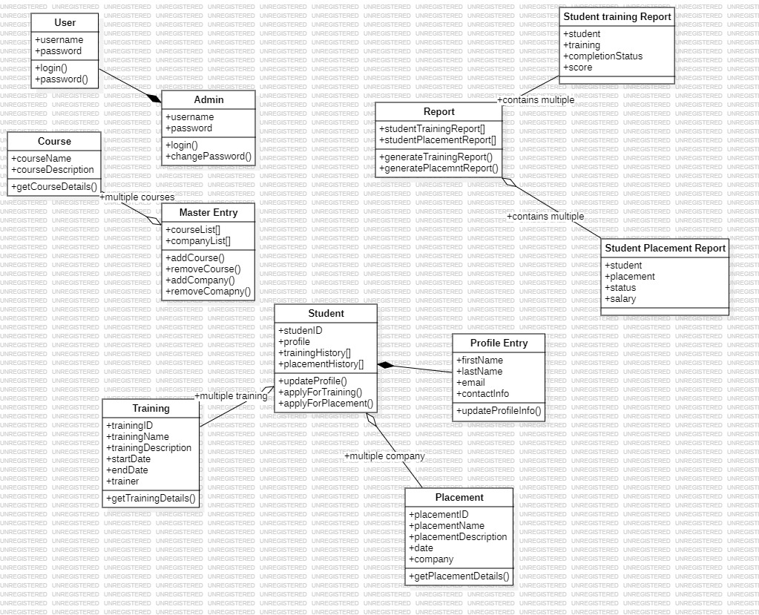

**Fig 3.1.7 UML Diagram**

**Chapter 4: Testing Methodologies**

**4.1 Types of Testing**

**4.1.1 Unit Testing:**

**Unit testing** is a software testing technique used in software development to evaluate individual units or components of a software application in isolation. The goal of unit testing is to ensure that each component, such as functions, methods, or classes, performs as designed and produces the correct output for a given input. Unit testing is typically performed by software developers during the development process, and it is a fundamental practice in modern software engineering. Here are some key aspects of unit testing:

1. **Isolation**: In unit testing, individual units or components of the software are tested in isolation. This means that the unit being tested is examined independently of the rest of the system. Any dependencies of the unit are often replaced with mock objects or stubs to ensure isolation.
2. **Automation**: Unit tests are automated, meaning they can be executed by a testing framework or tool without human intervention. This automation makes it possible to run tests frequently, helping to catch and address issues early in the development process.
3. **Repeatable**: Unit tests should produce the same results consistently. A well written unit test should not be affected by external factors and should be repeatable on different development environments.
4. **Fast**: Unit tests should execute quickly. They are designed to be fast so that developers can run them frequently during development, ensuring that any regressions are caught early.
5. **Whitebox Testing**: Unit testing often involves Whitebox testing, which means the tester has knowledge of the internal implementation details of the unit being tested. This knowledge helps in designing test cases that exercise different code paths within the unit.
6. **Assertions**: In unit testing, assertions are used to validate whether the actual output of the unit matches the expected results. If the actual and expected results do not match, the test fails, indicating a potential issue.
7. **Coverage**: Unit testing aims to achieve high code coverage, meaning that most, if not all, of the code in a unit is exercised by the tests. Tools can measure code coverage to ensure that tests are comprehensive.
8. **Regression Testing**: Unit tests serve as a form of regression testing, helping to catch unintended side effects or bugs introduced when changes are made to the codebase.

Unit testing is a foundational practice in test-driven development (TDD), where developers write tests before they write the actual code. This practice helps ensure that the code meets the requirements and functions correctly as it's being developed. Unit testing, when combined with integration testing and other testing techniques, contributes to the overall quality and reliability of a software application.

**4.1.2 Integration Testing:**

Integration testing is a software testing technique that focuses on verifying the interactions and interfaces between different components or modules of a software application. Its primary purpose is to ensure that the integrated parts of the system work together as expected, identifying and addressing issues related to the integration of various software components. Integration testing typically occurs after unit testing (where individual components or units are tested in isolation) and before system testing (where the entire software application is tested as a whole).

Key aspects of integration testing include:

Component Interaction: It checks how different modules, components, or services interact and communicate with each other. This interaction can involve data exchange, method calls, and message passing.

1. **Types of Integration Testing**: Integration testing can be performed using different approaches:
   1. **Top-Down Testing**: Testing is initiated from the top level of the application hierarchy, and lower-level components are gradually integrated and tested.
   2. **Bottom-Up Testing**: Testing starts from the lower-level components, and higher-level components are integrated incrementally.
   3. **Big Bang Testing**: All components are integrated simultaneously, and the entire system is tested as a whole.
   4. **Incremental Testing**: Components are integrated and tested incrementally, one by one.
2. **Stubs and Drivers**: In cases where not all components are available for testing at the same time, placeholders called "stubs" or "drivers" are used. Stubs simulate lower-level components for testing higher-level ones, and drivers simulate higher-level components for testing lower-level ones.
3. **Testing Scenarios**: Test scenarios are designed to cover various integration scenarios, ensuring that data flows correctly, interfaces are functioning properly, and that no unexpected issues arise during the interaction between components.
4. **Issues Detection**: Integration testing helps identify a wide range of issues, including data mismatch, communication problems, compatibility issues, interface errors, and timing issues.
5. **Isolation of Issues**: Integration testing helps isolate and resolve issues early in the development process, making it easier to track down the source of a problem.
6. **Regression Testing**: As components are integrated or modified, integration tests should be rerun to ensure that existing functionality remains unaffected.
7. **Integration Test Environments**: It's essential to create controlled test environments that simulate the actual integration scenarios as closely as possible. This may involve setting up test databases, servers, and network configurations.

Integration testing is a crucial step in the software development process because it ensures that individual components work together as intended to deliver the desired functionality. By catching integration issues early, software development teams can reduce the risk of more significant problems in later stages of development and deployment.

**4.1.3 User Interface Testing:**

User Interface (UI) testing for a Java Swing and MySQL desktop-based application involves verifying that the graphical user interface functions correctly and that user interactions with the application work as intended. Here are some steps to perform UI testing on a training and placement management application using Java Swing and MySQL:

1. **Understand the Application Requirements**:

Before starting UI testing, make sure you have a clear understanding of the application's requirements and expected behaviour. This includes knowledge of how the application should look, the features it should provide, and the flow of user interactions.

1. **Prepare Test Scenarios:**

Define test scenarios based on different user interactions and UI elements. These scenarios should cover common user tasks and edge cases. For a training and placement management application, this may include actions like adding a new student, updating placement records, generating reports, and managing user profiles.

1. **Test Environment Setup:**

Set up a test environment that mirrors the production environment as closely as possible. Ensure that the application is connected to a MySQL database with test data.

1. **Test Data Preparation:**

Create test data in the MySQL database to simulate real-world scenarios. This data should cover various combinations and edge cases to test different aspects of the application's functionality.

1. **Automated Testing (Optional):**

Consider automating UI testing using a testing framework such as Selenium or Java's Robot class for Swing applications. Automation can help streamline repetitive tests and improve test coverage.

1. **Manual Testing:**

Perform manual testing by following your predefined test scenarios. Testers should interact with the application just as end users would. Focus on the following aspects:

* 1. **Navigation**: Ensure that users can easily move between different sections of the application.
  2. **Input Validation**: Verify that the application validates user input and provides appropriate error messages for invalid data.
  3. **Data Retrieval**: Check if data is retrieved from the MySQL database accurately and displayed in the user interface.
  4. **Data Modification**: Test the ability to add, update, and delete records, and confirm that changes are reflected in the database.
  5. **UI Consistency**: Verify that the UI elements (buttons, forms, menus) are consistent and follow established design guidelines.
  6. **Error Handling**: Check how the application handles unexpected errors and exceptions.

1. **Compatibility Testing:**

Test the application on different operating systems and screen resolutions to ensure it functions correctly in various environments.

1. **Performance Testing:**

Assess the application's performance when dealing with a large amount of data. This can include measuring response times for data retrieval and complex operations.

1. **Security Testing:**

Verify that the application is secure and that user data is protected. Check for vulnerabilities such as SQL injection and data exposure.

1. **Documentation and Reporting:**

Document the test cases, test results, and any issues or bugs encountered during testing. This documentation can help developers address problems effectively.

1. **Regression Testing:**

After any changes or bug fixes, conduct regression testing to ensure that new updates do not introduce new issues or break existing functionality.

1. **User Acceptance Testing (UAT):**

Finally, involve end users or stakeholders in a user acceptance testing phase to ensure that the application meets their expectations and needs.

UI testing is an essential part of ensuring the quality and usability of a desktop-based application. It helps identify and address issues related to the user interface and interactions, ultimately delivering a more reliable and user-friendly product.

**4.1.4 Security Testing:**

Security testing is a critical aspect of the software development process that focuses on identifying vulnerabilities and weaknesses in a software application's security controls. The primary goal of security testing is to uncover potential security threats and mitigate them before they can be exploited by malicious actors. Here are some common types and methods of security testing:

1. **Vulnerability Assessment:** This involves scanning the software for known vulnerabilities, such as those listed in the National Vulnerability Database (NVD). Automated vulnerability scanning tools are often used to identify security flaws.
2. **Penetration Testing:** Penetration testers, also known as ethical hackers, actively attempt to exploit vulnerabilities in the software to assess its resilience against real-world attacks. They may use various techniques, such as network penetration testing, web application penetration testing, and social engineering.
3. **Security Scanning:** Automated security scanning tools can be used to identify security issues in both web applications and network infrastructure. These tools look for common vulnerabilities like SQL injection, cross site scripting (XSS), and insecure configurations.
4. **Code Review:** Manual or automated code review is performed to identify security flaws in the source code. This can include looking for issues like buffer overflows, input validation problems, and insecure data storage.
5. **Security Architecture Review:** This involves a high-level assessment of the software's architecture and design to identify potential security weaknesses that may exist at the structural level.
6. **Security Auditing:** Security audits involve a thorough examination of an application's code, design, and architecture to ensure it complies with best security practices and industry standards.
7. **Threat Modelling:** Threat modelling is a proactive approach to security testing that identifies potential threats and vulnerabilities during the design and planning phases of the software development process.
8. **Security Standards and Compliance Testing:** Ensure that the software complies with industry specific security standards and regulations, such as HIPAA for healthcare, GDPR for data protection, or PCI DSS for payment card data security.
9. **Authentication and Authorization Testing:** Verify that user authentication and authorization mechanisms are secure and cannot be easily bypassed.
10. **Data Encryption Testing:** Ensure that sensitive data is properly encrypted both at rest and in transit. This may involve checking the encryption algorithms and key management processes.
11. **Session Management Testing:** Evaluate the handling of user sessions to prevent session fixation, hijacking, and other session related vulnerabilities.
12. **API Security Testing:** Assess the security of APIs (Application Programming Interfaces) for web services and integrations. Check for vulnerabilities in API endpoints and the handling of data.
13. **Mobile App Security Testing:** Focuses on the unique security challenges of mobile applications, including issues related to device access, data storage, and communication.
14. **Network Security Testing:** Evaluate the security of network infrastructure, including firewalls, routers, and switches, to ensure that they are configured securely.
15. **Social Engineering Testing:** This type of testing assesses how susceptible employees or users are to social engineering attacks, such as phishing or impersonation.

Security testing is an ongoing process, and it's crucial to perform it regularly to address evolving security threats. Additionally, security testing should be integrated into the software development lifecycle from the earliest stages to minimize the risk of vulnerabilities going undetected.

**4.1.5 Load Testing:**

Load testing is a type of performance testing that assesses how a software application or system performs under various levels of load or user demand. The primary goal of load testing is to determine the application's response time, throughput, and stability when subjected to different levels of simulated user activity. Load testing helps identify performance bottlenecks and ensures that the system can handle its expected load without degradation of service. Here are the key aspects of load testing:

1. **Load:** Load represents the level of concurrent user activity or traffic that the system will experience during testing. It can be measured in terms of the number of users, transactions, or requests per second.
2. **Types of Load Testing:**
3. **Stress Testing:** This involves pushing the system beyond its expected capacity to identify breaking points and assess how it behaves under extreme loads.
4. **Load Testing:** Load testing aims to assess the system's performance under normal or expected loads, ensuring it meets performance criteria.
5. **Capacity Testing:** Capacity testing determines the maximum load the system can handle while maintaining acceptable performance.
6. **Test Scenarios:** Load testing involves creating test scenarios that simulate real-world usage patterns. These scenarios may include peak load (maximum expected users), sustained load (typical usage over time), and spike load (sudden bursts of activity).
7. **Key Metrics:** Load testing typically focuses on the following performance metrics:
8. **Response Time:** Measures how long it takes the system to respond to user requests.
9. **Throughput:** The number of transactions or requests processed per unit of time (e.g., requests per second).
10. **Error Rate:** Tracks the number of errors or failed transactions during the test.
11. **Resource Utilization:** Monitors CPU, memory, network, and other resource usage to identify bottlenecks.
12. **Tools:** Load testing is often automated, and there are various load testing tools available, such as Apache JMeter, LoadRunner, and Gatling. These tools help create test scenarios, simulate user activity, and collect performance metrics.
13. **Scalability Testing:** In addition to load testing, scalability testing assesses how well the system can scale to handle increased load. It aims to ensure that additional resources can be added to maintain or improve performance.
14. **Analysis and Reporting:** After conducting load tests, it's essential to analyse the results and create reports that highlight performance bottlenecks and suggest potential improvements. This information is crucial for optimizing the system's performance.
15. **Continuous Load Testing:** Load testing should be performed at different stages of the software development lifecycle, not just before production release. This helps identify and address performance issues early in development.
16. **Realistic Data:** Load testing scenarios should use realistic data and emulate user behaviours as closely as possible to ensure accurate results.
17. **Monitoring and Alerting:** During load testing, it's important to monitor the system in Realtime and set up alerts to identify performance degradation or failures.

Load testing is essential for ensuring that software applications and systems can handle the expected user load and deliver a satisfactory user experience. It helps prevent performance related issues, such as slow response times, server crashes, or data loss, when the application is used in production.

**4.2 Test Case Table:**

|  |  |  |  |  |  |
| --- | --- | --- | --- | --- | --- |
| **Test Case ID** | **Test Case Description** | **Test Steps** | **Expected Result** | **Actual Result** | **PASS/Fail** |
| TC001 | Verify login functionality | 1. Open the application 2. Enter valid credentials 3. Click the login button | User should log in successfully | Logged in successfully | **PASS** |
| TC002 | Verify login with incorrect credentials | 1. Open the application 2. Enter invalid credentials 3. Click the login button | Error message should be displayed | Error message is displayed | **PASS** |
| TC003 | Verify new student registration | 1. Open the Application 2. Login with Valid Credentials 3. Go to the Student | Student should be added to the database | Student is added to the database | **PASS** |
| TC004 | Verify updating student information | 1. Open the application. Select a student. 2. Update student information 3. Click "Save" | Student information should be updated in the database | Student information is updated in the database | **PASS** |
| TC005 | Verify placement record creation | * 1. Open the application   2. Click "Add Placement Record"   3. Fill in valid placement details  1. 4. Click "Save" | Placement record should be added to the database | Placement record is added to the database | **PASS** |
| TC006 | Verify placement record deletion | * 1. Open the application   2. Select a placement record  1. 3. Click "Delete" | Placement record should be removed from the database | Placement record is removed from the database | **PASS** |
| TC007 | Verify search functionality | * 1. Open the application   2. Enter search criteria  1. 3. Click "Search" | Results matching the search criteria should be displayed | Results matching the search criteria are displayed | **PASS** |
| TC008 | Verify data integrity with the database | 1. Connect to the database 2. Retrieve and compare data from the application and the database | Data in the application should match the data in the database | Data in the application matches data in the database | **PASS** |
| TC009 | Verify export functionality | 1. Open the application 2. Click "Export Data" 3. Choose a destination file 4. Click "Export" | Data should be exported to the specified file | Data is successfully exported to the specified file | **PASS** |
| TC010 | Verify system performance | 1. Simultaneously perform various actions within the application | The application should maintain good performance without crashing | The application maintains good performance without crashing | **PASS** |